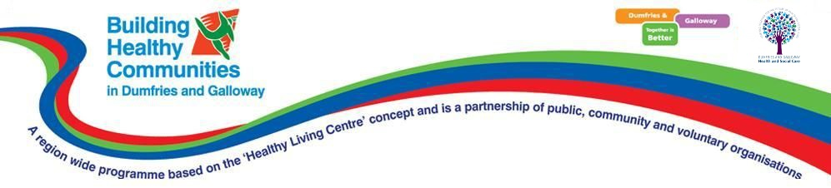**Building Healthy Communities**

**Preliminary Website Guide**

## Introduction

This is a guide to the Building Healthy Communities system, used to administer the various users and initiatives of the BHC programme. As the system is still under active development, this is only a preliminary guide designed to help with use of the currently existing features. When the system is complete, a more detailed and comprehensive guide will also be created.

## System Access and Login

At present, the system is hosted on a website called Heroku. The link to the site is as follows: <https://hidden-mountain-49766.herokuapp.com/>

When the system is accessed, you will be presented with this webpage:

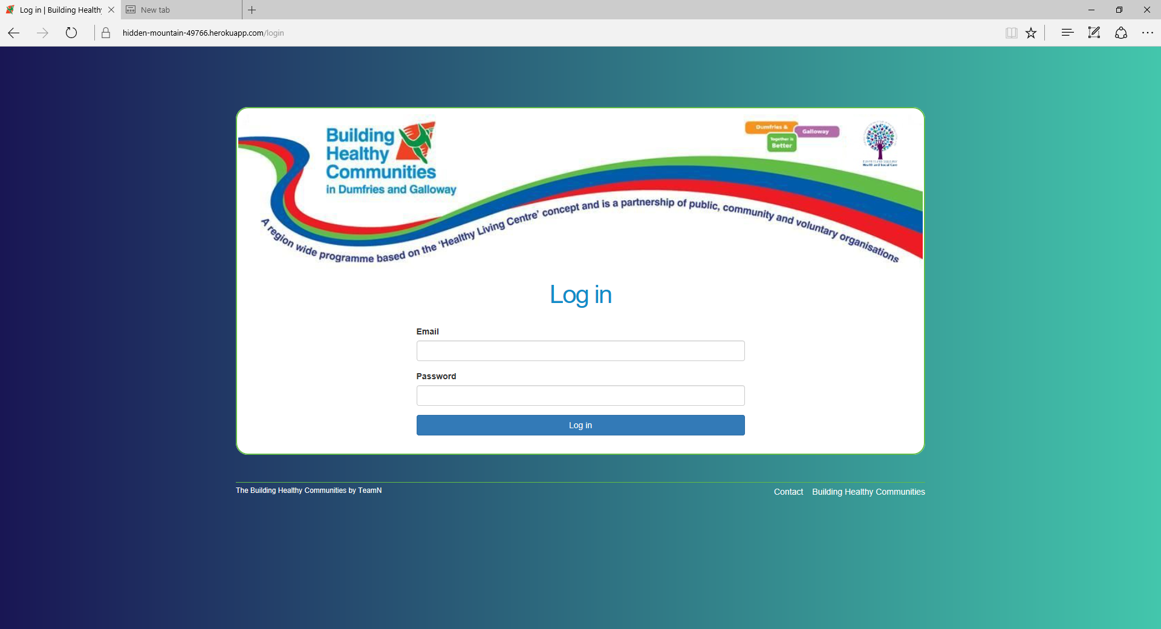

This is the only page accessible on the system until you log in. Log in using your admin, volunteer, or service user details, depending on what you want to access.

## Administrators

Administrators